MEDIA RELEASE
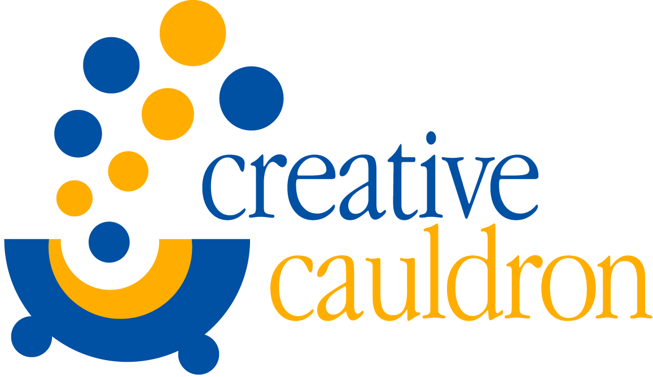
CONTACT: Amanda Lovins
703-436-9948 or 571-239-5288
alovins@creativecauldron.org
FOR IMMEDIATE RELEASE

Creative Cauldron Presents 6th Annual Passport to the World Concert Series
April 2 – 23, 2016 at ArtSpace Falls Church
Sponsored by Sislers Stone

[March 9, 2016], Falls Church, VA – Creative Cauldron’s 6th Annual Passport to the World Concert Series will be held from April 2nd to April 23rd at ArtSpace Falls Church, 410 South Maple Avenue. Presented in collaboration with the Folklore Society of Greater Washington and curated by local musicians Lynn Véronneau and Ken Avis (of acclaimed jazz-fusion group VERONNEAU), Passport to the World treats audiences to music and dance performances from a broad spectrum of genres: jazz, swing, Latin, classical, opera, klezmer and folk music. “Passport to the World is a festival rooted in worldly traditions,” says Véronneau. “Yet it’s decidedly modern. It’s thrilling and electrifying.” Tickets range from $18 to $24 and can be purchased online at www.creativecauldron.org or by calling 703-436-9948.

Passport Schedule
Saturday, April 2 at 7:30 PM – OCEAN Celtic Quartet
OCEAN is the winner of over 20 Washington Area Music Awards (Wammies) and has been hailed as “nothing short of spellbinding,” (The Washington Post). Ocean puts their unique spin on traditional songs and original compositions, from soaring ballads and stirring sea chantys to blazing fiddle and accordion tunes.
Sunday, April 3 at 6:00 PM – Seth Kibel Trio with Lena Seikaly
Seth Kibel is one of the Mid-Atlantic’s premier woodwind specialists, working with some of the best bands in jazz, swing and more. Lena Seikaly is a fresh voice on the national jazz scene from Washington, DC named “one of Washington’s preeminent jazz singers” and “brightest voices in jazz” (The Washington Post).
Thursday, April 7 at 7:30 PM – Cristian Perez Quintet
Defying all musical labels, Argentine guitarist/composer/teacher Cristian Perez weaves together genres from throughout the world. With a strong foundation in classical, jazz and South American music, he crafts a singular voice rich in sensitivity and nuance that freely explores the possibilities of the art form.
Friday, April 8 at 7:30 PM – Cissa Paz
Cissa Paz is a Brazilian singer-song writer. The diversity of her cultural experience merges with her fearless taste for new combinations as she creates and rearranges songs that are melded with the rich traditions of Afro-Brazilian and Luso-African concepts.
Saturday, April 9 at 7:30 PM – Words & Music Presents: Native American Premiere “Found Again”
Words & Music, Inc. is a Northern Virginia based vocal chamber ensemble, presenting innovative programs of classical and contemporary music. They have commissioned award-winning Native American composer, Jerod Tate, to write an original, multi-movement work for vocal quartet, piano, and small chorus. “Found Again,” will feature settings of five poems by Joy Harjo, a member of the Mvskoke Nation.
Sunday, April 10 at 6:00 PM – Akua Allrich
Jazz vocalist and DC native Akua Alrich has proven herself to be a musician of extraordinary talent and crowd-moving passion. With finesse and charisma, this vocalist, composer and teacher has successfully etched out a place for her unique musical expression, electrifying audiences with sold-out performances.
Friday, April 15 at 7:30 PM – Hot Club of Baltimore with Alexis Tantau
The Hot Club of Baltimore has quickly become the premiere Django Reinhardt style swing band in the U.S. Classical vocalist-turned-jazz- song-bird Alexis Tantau will complement the band with her performance of jazz manouche (French Gypsy Jazz) songs.
Saturday, April 16 at 2:00 pm Juan Cayrampoma and the Andean Scissors Dancers
Juan Cayrampoma, from the Andean/Latin fusion group Raymi, joins forces with traditional Andean Scissors Dancers to bring you the haunting sounds and mystic power of the Andes, and an original dance from one of the deepest Highland regions of Peru.

Saturday, April 16 at 7:30 PM – Shenandoah Run
Shenandoah Run blends vintage and contemporary folk music in a manner that appeals to all listeners. The nine-member ensemble presents the songs and sounds of American folk, with an occasional infusion of songs from other lands and from the worlds of country and bluegrass.
Sunday, April 17 at 2:00 PM – Carpathia Folk Dance Ensemble
Carpathia Folk Dance Ensemble presents dances from a variety of Central & Eastern European countries including Ukraine, Poland, Germany, Romania, and Bulgaria, among others. Their dances represent the wide variety of couple and line dance styles found throughout the region.
Sunday, April 17 at 6:00 PM – Dave Kline Band
The Dave Kline Band is a Washington, D.C. based group recognized for its vibrant world sound blending the modern genres of rock, blues, jazz and folk with music from ancient cultures such as Africa, the Caribbean, the Middle East, Europe and Latin America.
Friday, April 22 at 8:00 PM – Urban Arias “Craigslist Cabaret”
Urban Arias is the DC area’s premiere contemporary opera company, with a flair for crossover. In their “Craigslist Cabaret” they present 8 hilarious REAL Craigslist ads set to music—plus, the witty “Buyer Beware: Songs from a Supermarket Bulletin Board,” and the touching “Farmball Songs.”
Saturday, April 23 at 7:30 PM – VERONNEAU
International acoustic quartet, Veronneau perform a delicious blend of bossa nova, jazz, samba and swing in English, French, Spanish and Portuguese that has been captivating festival, concert hall and jazz club audiences across North America and Europe.

Fact Sheet
Who: Creative Cauldron, in collaboration with the Folklore Society of Greater Washington. Curated by Lynn Véronneau and Ken Avis (of VERONNEAU).
What: The 6th Annual Passport to the World Concert Series
When: April 2- 23, 2016 (for detailed schedule, see “Passport Schedule” above).
Where: Creative Cauldron at Artspace Falls Church
410 South Maple Avenue
Falls Church, VA 22046 Free Parking in 410 and 400 South Maple Building Garages
Ticket Prices*: $20 Adults $18 Students/Seniors/Military
$100 Table for 4 with bottle of Wine
$50 Table for 2 with 2 glasses of Wine
*All concerts except Urban Arias ($24 Adults $22 Students/Seniors/Military
Table for 4 $116 Table for 2 $58)
Info/Tickets: www.creativecauldron.org (703) 436-9948

Creative Cauldron programs are funded in part through grants from the Arts Council of Fairfax County, the Virginia Commission for the Arts, the National Endowment for the Arts, The Little City Catch Foundation. Creative Cauldron also receives generous support from individuals and corporations.

