MEDIA RELEASE
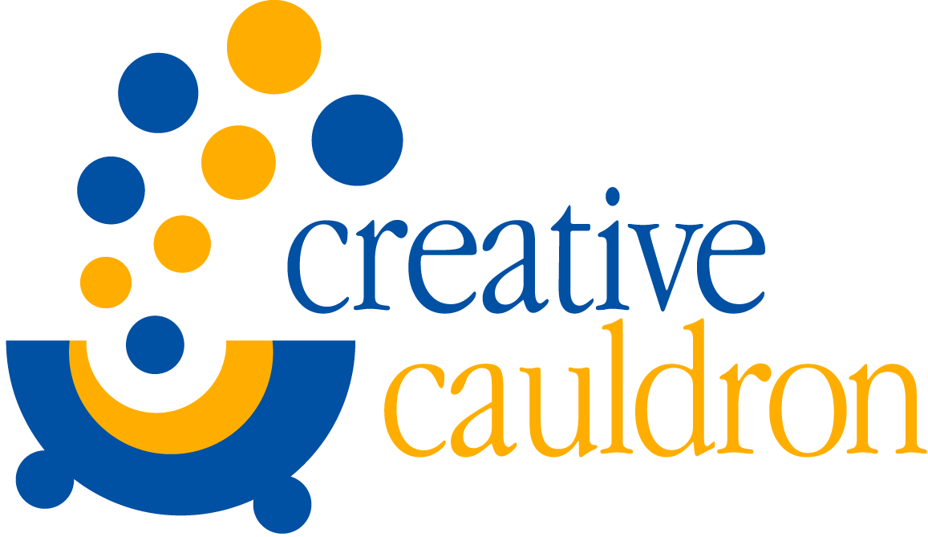
CONTACT: Amanda Lovins
703-436-9948 or 571-239-5288
alovins@creativecauldron.org
FOR IMMEDIATE RELEASE

Creative Cauldron Presents Madeline and the Gypsies
December 5 - 27 at ArtSpace Falls Church

Falls Church, VA Creative Cauldron will ring in the holidays with Madeline’s and the Gypsies, a musical adaptation of the classic book by the author/illustrator Ludwig Bemelmans. Barry Kornhauser adapted the book and Michael Koerner wrote the musical score. The production is directed and choreographed by Matt Conner. Scenic and Costume Designer Margie Jervis and Lighting Designer John Sami have created a whimsical visual world for the play inspired by Bemelmans’ classic illustrations. Madeline and the Gypsies runs from December 4 – 27, 2015 at ArtSpace Falls Church, 410 South Maple Avenue. Curtain times are Fridays at 7:30 pm, Saturdays at 2:00 pm and 7:30 pm, and Sundays at 2:00 pm with an additional performance on December 27 at 4:30 pm. Press night is Saturday, December 5 at 7:30 pm.
“In and Old house in Paris that was covered with vines lived twelve little girls in two straight lines.” With that familiar phrase, Bemelmans set in motion the adventures of a precocious little girl named Madeline, winning the hearts of generations of readers to come. After last season’s sold out production of Madeline’s Christmas, Madeline returns to the cauldron for another adventure in the Bemelman series. While visiting a traveling carnival in town, Madeline and her friend, Pepito, become trapped on top of the Ferris wheel and separated from her classmates during a sudden rainstorm. Soon they are swept away by the gypsies and become a part of the carnival themselves! A madcap adventure ensues as Madeline and Pepito embrace the gypsy life.
The twelve little girls, and a resident mouse, will be played by members of Creative Cauldron’s Learning Theater Ensemble, with Piper Boatwright and Talia Cutler sharing the role of Madeline. The cast also includes Carli Smith as Miss Clavel, the intrepid head of the Catholic boarding school. Carli was most recently seen in Creative Cauldron’s Helen Hayes Awards© Recommended production of The World Goes Round. Other regional credits include playing Elle Woods in Legally Blonde and Sandy in Grease with the Margate City Players. The professional adult cast also includes Laura Connors Hull as the Gypsy Mama, Scott Harrison as the Strongman, and Ethan Miller as the Clown. Laura is the Producing Director of Creative Cauldron and appeared as Mrs. Murphy, the Irish cook, in last season’s Madeline’s Christmas. Scott’s regional credits include: Mendel in Fiddler on the Roof at Arena Stage, as Rapunzel’s Prince in Into the Woods at Next Stop Theatre Company, and the Steward in Into the Woods at Toby’s Dinner Theatre. Ethan Miller appeared last season as Miles in Creative Cauldron’s critically acclaimed world premiere musical The Turn of the Screw.
Tickets for Madeline and the Gypsies can be purchased online at www.creativecauldron.org or by calling 703-436-9948.
Creative Cauldron is a non-profit arts organization whose innovative programs in the performing and visual arts embody collaboration, experimentation and community engagement. Creative Cauldron was founded by Producing Director, Laura Connors Hull, in 2002. In June of 2009, Creative Cauldron acquired a permanent home in ArtSpace Falls Church, a 3,000 square foot flexible arts space that provides a venue for year-round classes, live performances of theater, music and dance and visual art exhibits. Programs are presented in part through grants from the Virginia Commission for the Arts, The National Endowment for the Arts, the Arts Council of Fairfax County, the City of Falls Church and the Little City CATCH Foundation.
FACT SHEET:
Who/What: Creative Cauldron’s Production of Madeline and the Gypsies
Adapted for the stage by Barry Kornhauser
Music by Michael Koerner
Based on the Book by Ludwig Bemelmans

When: Production runs December 4 – 27, 2015
Fridays at 7:30 pm, Saturdays at 2:00 pm and 7:30 pm,
Sundays at 2:00 pm, No Performance December 25th
Additional Performance Sunday, December 27 at 4:30 pm

Where: Creative Cauldron at ArtSpace Falls Church
410 South Maple Avenue, Falls Church, VA 22046

Info: Tickets Adults $20 Students/Seniors/Military $18
Season Passes and Discounts for Groups of 10 or more available
www.creativecauldron.org or 703-436-9948
Free Parking is available in the 410 and 400 South Maple Building Garages

