MEDIA RELEASE
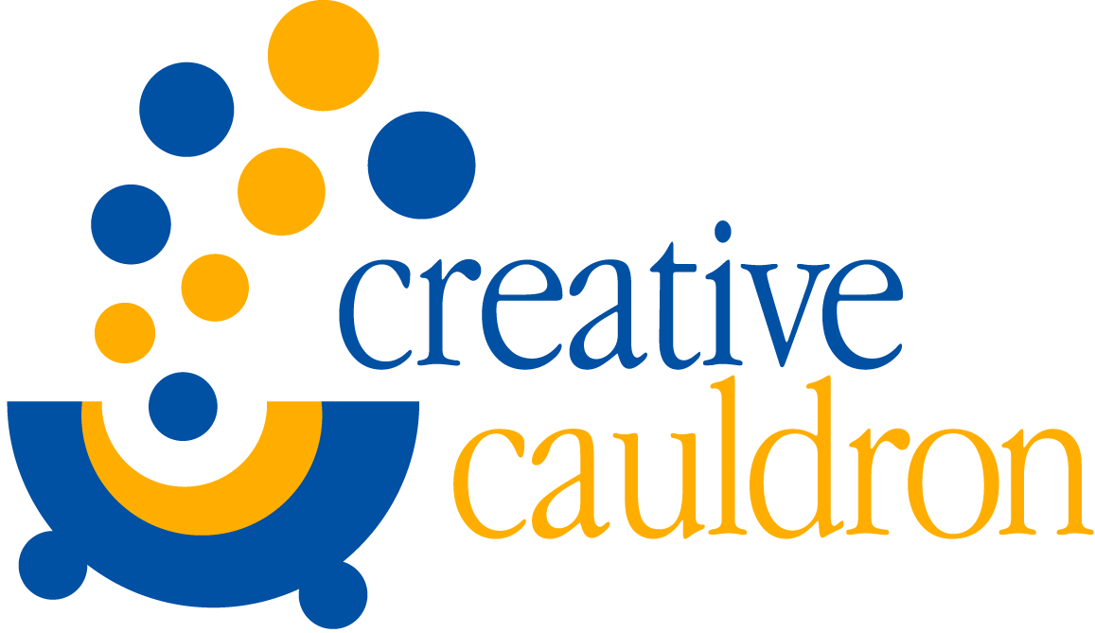
CONTACT: Amanda Lovins
703-436-9948 or 571-239-5288
alovins@creativecauldron.org
FOR IMMEDIATE RELEASE

Creative Cauldron opens 2015-16 Season with Kander and Ebb Musical Revue
The World Goes ‘Round

Falls Church, VA Creative Cauldron will open its 2015-16 season with The World Goes ‘Round, a musical revue of works by John Kander and Fred Ebb, one of the most prolific and acclaimed Broadway musical creative teams of all time. The production is directed by Matt Conner and choreographed by Kara-Tameika Watkins. “Audiences will be dazzled by the brilliance of Kander and Ebb,” stated Conner. “The songs in this wonderful revue celebrate the resilience of the human heart on a revolving planet filled with love, pain, success and failure.” Previews begin October 1st and the show continues at ArtSpace Falls Church (410 South Maple Avenue) through October 25th. A Season Opening Gala reception and performance will be held on Saturday, October 3rd beginning at 6:30 pm. Press Night is Sunday, October 4th at 7:00 pm
The World Goes ‘Round was conceived by director Scott Ellis, choreographer Susan Stroman, and librettist David Thompson, and was first presented off-Broadway to critical raves in 1991. It won the Lucille Lortel Award for Outstanding Musical, and the Drama Desk Award for Outstanding Musical Revue. Audiences are taken on a journey through an eclectic collection of love songs, torch songs, and acerbically witty numbers from Kander and Ebb shows, including showstoppers like “Cabaret” and “New York, New York” to lesser-known gems like “A Quiet Thing” from Flora the Red Menace. The entire collection represents Kander and Ebb’s major work over 26 years of collaboration with songs from: The Happy Time, Woman of the Year, Chicago, Funny Lady, Flora the Red Menace, Kiss of the Spider Woman and Cabaret and the movie New York, New York.
Director Matt Conner has been an associate artist with Creative Cauldron for the past thirteen years. Conner is a well-known composer whose works have been performed at Signature Theatre and at other professional venues in the metropolitan DC area. Matt’s critically acclaimed musical The Turn of the Screw premiered at Creative Cauldron this past year. Kara-Tameika Watkins is a veteran musical theater performer and choreographer who has worked on numerous projects at Creative Cauldron including last season’s Helen Hayes Awards © Recommended production of Once on This Island.
Katie McManus, Harv Lester, Jordan DeBona, Carolyn Burke and Carli Smith will appear in the professional cast. Katie appeared at Creative Cauldron in last season’s production of Jacques Brel is Alive and Well and Living in Paris, which received a Helen Hayes Awards © nomination for Outstanding Ensemble in a Musical. She has also appeared at numerous DC metro area theaters including NextStop Theatre, Ford's Theatre, Studio Theatre, Signature Theatre and Keegan Theatre, and as a guest soloist for the Gay Men’s Chorus of Washington, D.C. at the Kennedy Center.
Harv Lester has appeared at Keegan Theatre, Signature Theatre, WSC Avant Bard, the New York Int’l Fringe Festival, Capital Fringe Festival and THEARC Theater (Anacostia). Carolyn Burke, a newcomer on the DC theater scene, appeared in Swing Time the Musical, Burke Theater and A Family Reunion, Capital Fringe. Her regional credits include Ivoryton Playhouse, Connecticut Repertory Theaterm Playhouse on Park and Philipstown Depot Theatre, NY. Carli Smith, also a DC newcomer, appeared in Tarzan the Stage Musical (Jane) Milburn Stone Theatre, Legally Blonde: the Musical (Elle Woods) at Charm City Theatre and Margate City Theatre, and Grease (Sandy) also at Margate City Theatre. Jordan DeBona just completed a run as Leroy in Signature Theatre’s The Fix where he also appeared in the ensemble of Cabaret. Other regional credits include the Pittsburgh Musical Theatre, Chartiers Valley Theatre Company and the Greensburg Civic Theater.

Performances are Thursday through Saturday at 8:00 pm and Sundays at 2:00 pm and 7:00 pm.
Tickets are $26 for General Admission and $24 for students, seniors and military.
Tickets for The World Goes Round can be purchased on www.creativecauldron.org or by calling 703-436-9948.
#####

FACT SHEET:
Who/What: Creative Cauldron’s The World Goes ‘Round
Music by John Kander
Lyrics by Fred Ebb
Conceived by Susan Stroman, David Thompson, Scott Ellis
Directed by Matt Conner
Featuring Katie McManus, Harv Lester, Carolyn Burke, Jordan DeBona and Carli Smith

When: Production runs October 1 through 25
Thursdays thru Saturdays at 8:00pm, Sundays at 2:00 pm and 7:00 pm
Special Premiere Gala Performance Saturday, October 3 at 6:30 pm
Press Night Sunday, October 4 at 7:00 pm

Where: Creative Cauldron at ArtSpace Falls Church
410 South Maple Avenue, Falls Church, VA 22046

Info: Tickets Adults $26 Students/Seniors/Military $24
Premier Gala Performance on October 3 at 6:30 pm $100
Season Flex Passes and Discounts for Groups of 10 or more
www.creativecauldron.org or 703-436-9948
Free Parking is available in the 410 and 400 South Maple Building Garages

