MEDIA RELEASE
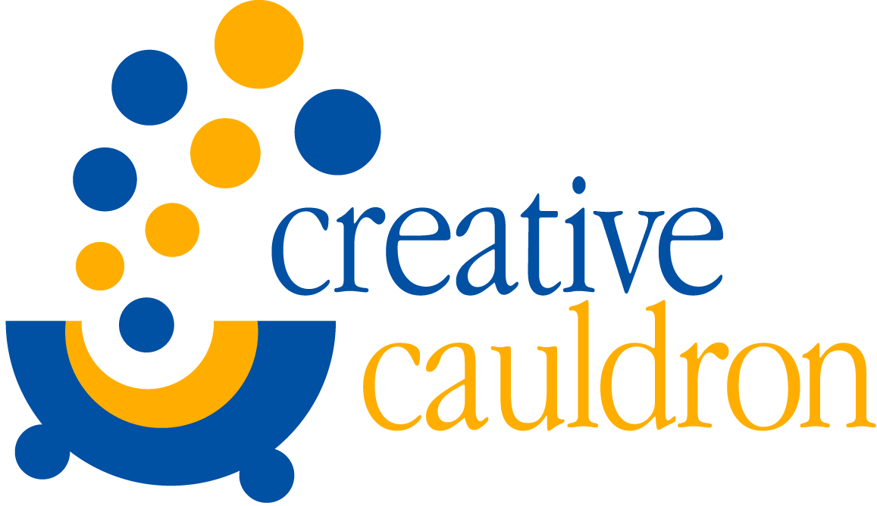
CONTACT: Amanda Lovins
703-436-9948 or 571-239-5288
alovins@creativecauldron.org
FOR IMMEDIATE RELEASE

Creative Cauldron Presents Scorching Musical Blues in the Night
February 9 – March 5, 2017 at ArtSpace Falls Church

Falls Church, VA – Creative Cauldron presents the Tony-Award Nominated Musical Blues in the Night, directed by Creative Cauldron’s Artistic Associate, Matt Conner. Set in a rundown hotel in Chicago 1938, Blues in the Night was conceived and originally directed by Sheldon Epps. It weaves a breadth of stories defined through twenty-six classic songs that cover the range of the quintessential American art form. The show takes its title from the Academy Award-Nominated blues standard by Harold Arlen and Johnny Mercer. The first act features lush big band numbers like “Am I Blue?”, made famous by Eddie Cochran and Ray Charles, and “I Gotta Right to Sing the Blues”, a Billie Holiday standard. It also features raunchy tunes like “Rough and Ready Man” and “Reckless Blues”, favorites of Alberta Hunter and Bessie Smith. The soulful voices of Ella Fitzgerald, Etta James and Nina Simone can be heard in the second act’s heartfelt torch songs like “These Foolish Things (Remind Me of You)” and “Willow Weep for Me”.
Creative Cauldron’s Blues in the Night will feature Iyona Blake, Katie McManus, Raquel Gregory-Jennings and Clifton Walker III. Creative Cauldron veteran Iyona Blake starred in last season’s critically-acclaimed Caroline, or Change, for which she received the BroadwayWorld DC award for Best Actress in a Musical – Small Theatre Production. She has performed as Asaka in Creative Cauldron’s 2016 Helen Hayes Awards © Nominated Once on This Island and as Good Sister in Creative Cauldron’s 2013 production of Thunder Knocking on the Door. Katie McManus returns to the Cauldron after her critically-acclaimed performance in Ruthless! The Musical earlier this season. She has previously performed in Creative Cauldron’s The World Goes ‘Round and Helen Hayes Awards © Nominated Jacques Brel is Alive and Well and Living in Paris. Raquel Gregory-Jennings makes her Creative Cauldron debut, and appeared with ArtsCentric in Baltimore, MD and in AIDA at the Annapolis Opera Company. Clifton Walker III also makes his Creative Cauldron debut, and appeared in Two Gentlemen of Verona (a rock opera) at Shakespeare Theatre Company, at The Kennedy Center with Chita Rivera and Rita Moreno, and as Papa Ge in Once on This Island at Roundhouse Theatre.
Director Matt Conner directed Creative Cauldron’s Helen Hayes Awards © Recommended productions of Ruthless! The Musical and Caroline, or Change. He was awarded the BroadwayWorld DC award for Best Direction – Small Professional Theatre with Stephen Gregory Smith for 2016’s Monsters of the Villa Diodati. Conner and Smith hold a Helen Hayes Award © Nomination for Outstanding Director of a Musical – HELEN Production for Creative Cauldron’s 2015 production of The Turn of the Screw. Their third Bold New Works world premiere, Kaleidoscope, will appear at Creative Cauldron in May, 2017.

The creative team for Blues in the Night includes Walter “Bobby” McCoy as Music Director, Margie Jervis as Scenic and Costume Designer, and Lynn Joslin as Lighting Designer.

Tickets for Blues in the Night can be purchased at creativecauldron.org or by calling 703-436-9948.
#####

Creative Cauldron is a non-profit arts organization whose innovative programs in the performing and visual arts embody collaboration, experimentation and community engagement. Creative Cauldron was founded by Producing Director Laura Connors Hull in 2002. In June of 2009, Creative Cauldron acquired a permanent home in ArtSpace Falls Church, a 3,000 square foot flexible arts space that provides a venue for year-round classes, live performances of theater, music and dance and visual art exhibits. Programs are presented in part through grants from the Virginia Commission for the Arts, The National Endowment for the Arts, the Arts Council of Fairfax County, the City of Falls Church and the Little City CATCH Foundation. Creative Cauldron’s programs are also supported by generous corporate and individual sponsors.
FACT SHEET

Who/What: Creative Cauldron’s Presents: Blues in the Night
Conceived and Originally Directed by Sheldon Epps
Original Vocal Arrangements and Musical Direction by Chapman Roberts
Orchestrations and Additional Vocal Arrangements by Sy Johnson

Creative Cauldron Production Directed by Matt Conner
Starring Iyona Blake, Katie McManus, Raquel Gregory-Jennings & Clifton Walker III
Creative Team featuring Walter “Bobby” McCoy (Music Director), Margie Jervis (Scenic and Costume Designer) and Lynn Joslin (Lighting Designer)

When: Production runs February 9 – March 5, 2017
Thursdays, Fridays and Saturdays at 8:00 PM, Sundays at 2:00 PM and 7:00 PM
Press Night/Premiere Gala is Saturday, February 11th, 2017 at 8:00 PM

Where: Creative Cauldron at ArtSpace Falls Church
410 South Maple Avenue, Falls Church, VA 22046

Ticket Info: Adults: $30 | Seniors/Military: $26 | Students: $20
Season Passes and Discounts for Groups of 10 or more available
www.creativecauldron.org or 703-436-9948
Free Parking is available in the 410 and 400 South Maple Building Garages

